# **Anaerobic Gram-Negative Rods (Bacteroides, Prevotella, Fusobacterium, etc.)**

**About:** The anaerobic GNRs are normal flora of the gut, oral cavity, and genitourinary tract, and cause polymicrobial infections (abscesses, peritonitis, aspirations).

**Key groups**: Bacteroides fragilis group, Prevotella, Porphyromonas, Fusobacterium, among others.

They vary in morphology (from pleomorphic rods to spindle-shaped).

**obligate anaerobes** (no growth in air).

4 main possibilities: Fusobacterium, Bacteroides, Prevotella, Porphyrmonas.

* Only Fuso can be distinguished by Gram (spindle like)
* *Bacteroides fragilis* often are safety-pin or vacuolated rod
* *Prevotella* and *Porphyromonas* can be coccobacillary.
* Porphyromonas has brick-red fluorescence
* Aesculin positive suggests it is Bacteroides
* Catalase positive means it is not Fuso or Porphyromonas

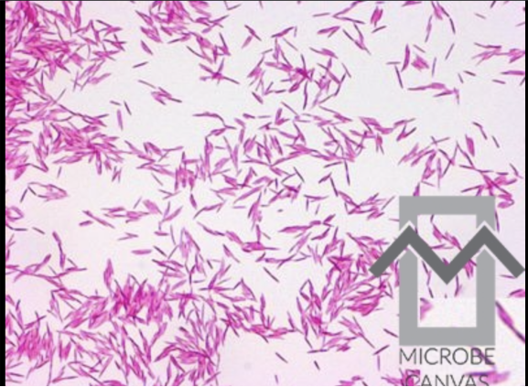

**Antibiotic disk tests (Special-potency disks):**

Presumptive ID method: **Kanamycin, Vancomycin, Colistin**.

* *Bacteroides fragilis group:* Resistant to all three: Kanamycin R, Vancomycin R, Colistin R.
* *Fusobacterium:* Typically **Sensitive to Kanamycin**, **Resistant to Vancomycin**, Variable to Colistin (often sensitive).
* *Prevotella/Porphyromonas:* Generally **Resistant to Kanamycin**, **Resistant to Colistin**, **Variable to Vancomycin**.
* *Porphyromonas* (like P. gingivalis) is usually **Vanco sensitive**

|  |  |  |  |
| --- | --- | --- | --- |
|  | Kanamycin | Vancomycin | Colistin |
| Bacteroides | R | R | R |
| Fusobacterium | S | R | V |
| Prevotella | R | V | R |
| Porphyromonas | R | S | R |

* *Veillonella* (anaerobic GNC) is vancomycin sensitive too, but not our focus here. - These patterns plus other tests direct ID.

**Other testing**

* **Bile tolerance:** Bacteroides fragilis group are **bile-resistant** (can grow in 20% bile, hence black on BBE agar by esculin hydrolysis). Most other anaerobes are inhibited by bile.
* **Pigment production & fluorescence:** **Prevotella** and **Porphyromonas** species form **brown-black pigmented colonies** over a week (and show **brick-red fluorescence under long-wave UV light (365 nm)** due to porphyrins. -
* *Prevotella* are saccharolytic (ferment sugars) whereas *Porphyromonas* are asaccharolytic.
* **Indole production:**
  + *Bacteroides fragilis* group: variable (B. fragilis itself often indole negative, B. thetaiotaomicron indole positive).
  + *Prevotella* – variable indole.
  + *Porphyromonas* – often **indole positive** (P. gingivalis is indole +).
  + *Fusobacterium nucleatum* – **indole positive** (a notable trait) and also fluoresces chartreuse.
  + *Fusobacterium necrophorum* – indole positive, lipase positive, very virulent (Lemierre’s syndrome organism).
* **Lipase:** *Fusobacterium necrophorum* is **lipase positive** (oil slick sheen on egg yolk).
* **Urease:** *Bacteroides ureolyticus* (now Campylobacter ureolyticus technically) is urease positive and pits agar; it’s microaerophilic actually. - *Helicobacter (Anaerobiospirillum) succiniciproducens* from dog bite is also urease positive but extremely rare.

**Major Groups Specifics:**

* **Bacteroides fragilis group:**
  + e.g. *B. fragilis, B. thetaiotaomicron, B. ovatus, B. vulgatus, etc.*
  + pleomorphic Gram-negative rods with rounded ends.
  + **bile-resistant** and **esculin-positive** (bile-esculin agar turns black).
  + **Catalase positive** (often), **indole variable**.
  + They do not fluoresce under UV.
  + They are **resistant to Kanamycin, Vancomycin, Colistin** (special disk pattern: RRR).
  + They are the most common anaerobes in human colon and frequently isolated from intraabdominal abscesses.
  + Notably, *B. fragilis* has a polysaccharide capsule aiding in abscess formation and often produces β-lactamase (penicillin resistant).
* **Prevotella:**
  + Small Gram-negative rods,
  + some pigmented.
  + **Prevotella melaninogenica** group (pigmented Prevotellas) are oral flora that cause aspiration pneumonia, dental infections.
  + show brick-red fluorescence under UV early on.
  + Prevotella are **vancomycin resistant, kanamycin resistant**, and usually **colistin resistant** (pattern R R R, same as Bacteroides for many Prevotella).
* **Porphyromonas:**
  + Similar to Prevotella but generally **assacharolytic** (don’t ferment carbohydrates)
  + **vancomycin sensitive** (unique for a Gram-negative rod).
  + *Porphyromonas gingivalis* (oral, causes periodontal disease) is pigmented (black colonies)
  + **brick-red fluorescence**,
  + **indole positive**
* **Fusobacterium:**
  + *F. nucleatum* – spindles.
    - Colonies can be speck-like or bread-crumb textured.
    - **chartreuse (green-yellow) fluorescence** under UV.
    - Indole **positive**.
    - **Kanamycin S, Colistin S, Vancomycin R**.
    - Common in oral flora, aspiration lung abscesses.
  + *F. necrophorum*
    - more pleomorphic rods,
    - Lemierre’s syndrome
    - **Indole positive, lipase positive, chartreuse fluorescence**.
    - Can be beta-hemolytic on blood agar.
    - *F. varium* etc. – not as distinct. -
* **Others:** 
  + *Bilophila wadsworthia* – found in appendicitis; it's **bile-resistant** and **H₂S positive** (colonies black on BBE agar without the whole media turning black). Also catalase pos, nitrate pos.
  + *Leptotrichia, Sneathia* – oral/vaginal anaerobes (Gram-variable filamentous rods).
  + *Mobiluncus* – curved anaerobic rods associated with bacterial vaginosis (Gram variable curved rods, motile, part of BV “clue cells” mix).

**Identification Process in Lab:**

* **Anaerobic culture** yields isolates. First, determine if Gram-negative rod. Use **aerotolerance test**
* D**isk tests (Kan/Vanc/Col)** on anaerobic blood plate
* Check for **pigment and fluorescence** under UV after 48h.
* **indole** test
* Any **specialty tests** as needed:
  + catalase (for B. fragilis, using 15% H₂O₂),
  + lipase on egg yolk (for Fusobacterium).
* By combining:
  + Bacteroides fragilis group: Growth on BBE (black colonies), catalase +, indole variable, resistant to all 3 disks.
  + Prevotella: black pigment + red fluorescence suggests Prevotella/Porphyromonas; if it grows on LKV agar (has kanamycin + vanc) but not on BAP with vancomycin disk, likely Prevotella (vanc R). Indole variable (Prevotella melaninogenica indole neg).
  + Porphyromonas: pigmented but vancomycin S (so won’t grow on LKV, and a 5 μg vancomycin disk would show zone).
  + Fusobacterium: chartreuse fluorescence, indole + (at least for F. nucleatum and necrophorum), Kanamycin S, often bread-crumb colonies.